Alyson Rosenberg

206 Final Project Report

1. ***Your goals***

My goals for this project were to successfully utilize multiple APIs to extract meaningful data that is relevant to my life, and my online interactions. I then wanted to load all of my data into an SQL database where I could easily sort through, manage, and view all of the data I extracted. Then, I wanted to pick out some of the data from a few APIs and create fun and visually appealing ways to display the data.

My goals also included getting all of the possible points on this project. I utilized 5 APIS and 3 visualizations.

1. ***Which goals you achieved***

I achieved all of my intended goals.

1. ***What problems you faced***

I did face a few problems while working on my project. At first, in my initial plan, I indicated that I would use Google Maps as one of my APIs. However, I noticed that Google Maps has various API types, but all which require user input and output only around one specific thing. For example, one API I tried to work with required a user to input a location starting point, and end point and only outputted information about that one route. For the purpose of this project, I wanted to use APIs where I could obtain more information at once. I ended up not using Google Maps API.

While working on this project I faced an issue where I got the error: Type error: ‘TypeNone’ object is not suscriptible for my IMDB movie API. I got this error for Instagram too. I added the line in my code if movieinfo != None: which helped solve this problem. I had to debug my code by including numerous print statements until I could trace the problem.

While working with my visuals, I faced a few problems on plotly. I got a lot of errors that “field not valid.” I had to carefully figure out the specific parameters of each function. I also had to find the best way to display the data. My third visualization is of the amount of likes each post gets. At first, I faced an issue determining the intervals I would use on the axis. I wanted my data to be displayed as clear as possible to the user.

1. ***Your social media “report”***

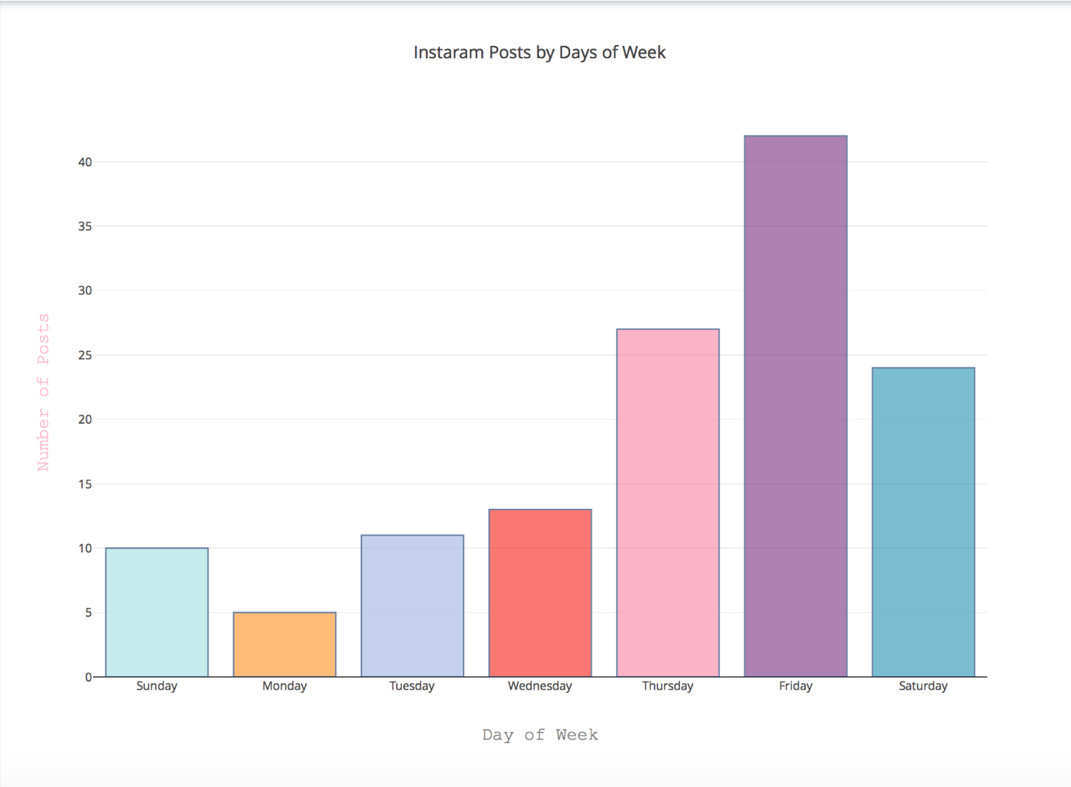

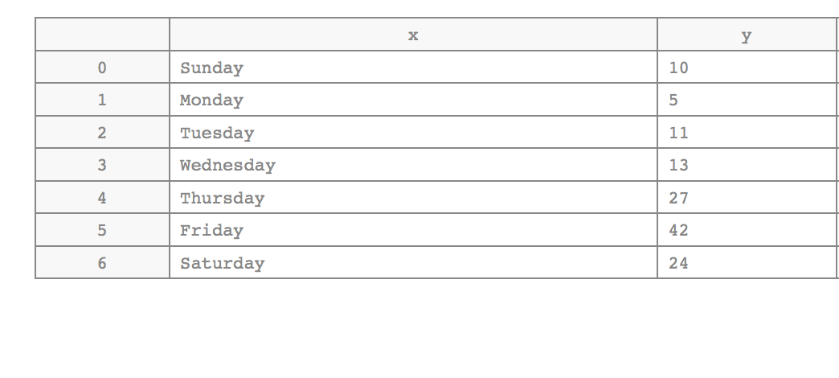

1. ***Instructions for running your code.***

* Navigate to folder with code (final.py)
* From terminal, run “python final.py”
* To access my visualizations, copy and paste the following link in your browser “https://plot.ly/~alyrosenberg”

1. ***Documentation for each function you wrote (Code must be fully formatted and you must include ALL resources used.)***

In my code, I commented what each part of the function does.

|  |  |  |  |
| --- | --- | --- | --- |
| DATE | ISSUE DESCRIPTION | LOCATION OF RESOURCE | RESULT (did it solve the issue?) |
| 11/29/17 | Type error: ‘TypeNone’ object is not suscriptible for my IMDB movie API | https://stackoverflow.com/questions/3887381/typeerror-nonetype-object-is-not-iterable-in-python | yes |
| 12/1/17 | JSON object is not subscriptable | https://stackoverflow.com/questions/34508981/response-object-is-not-subscriptable-python-http-post-request | yes |
| 12/10/17 | Plotly field not valid | https://plot.ly/python/pie-charts/ | yes |

***APIS:***

1. ***Instagram***- I obtained data from my personal handle (@alyrosenberg) for information from 132 of my posts. I obtained the id number, the time the post was created, the caption of the post, the number of likes the post has, as well as the latitude and longitude of where the post was posted. I loaded all this information into the database and then made visualizations from this data which I will discuss later in this report.

2.***Github*** – I got information from 30 of my github events (using my own username: alyrosenberg). I got the ID of the event, the time the event was created, the type of event, and the repository name. I successfully loaded this data into a database.

3.***OMDB***- for this API, I got information from 26 movies. I got the title of the movies, the director, the year the movie was released, the genre of the movie and its IMDB rating and inputted this data into the database. As I will discuss later, I created a visualization on plotly regarding the movie genres.

4. ***Pokemon*** – I used the Pokemon API to get data for 250 pokemons. I obtained their name, id, height, weight and base experience number, and loaded all of that information into a database.

5. ***iTunes*** – I obtained 150 results for 3 artists: Justin Bieber, Miley Cyrus and Beyonce. I got the artist ID, the track name and the track number.

***Visualizations:*** <https://plot.ly/~alyrosenberg>

I listed more visualizations in my plan because I was unsure which would be most helpful to display my information. I ended up choosing the following:

1. Instagram posts by days of the week:

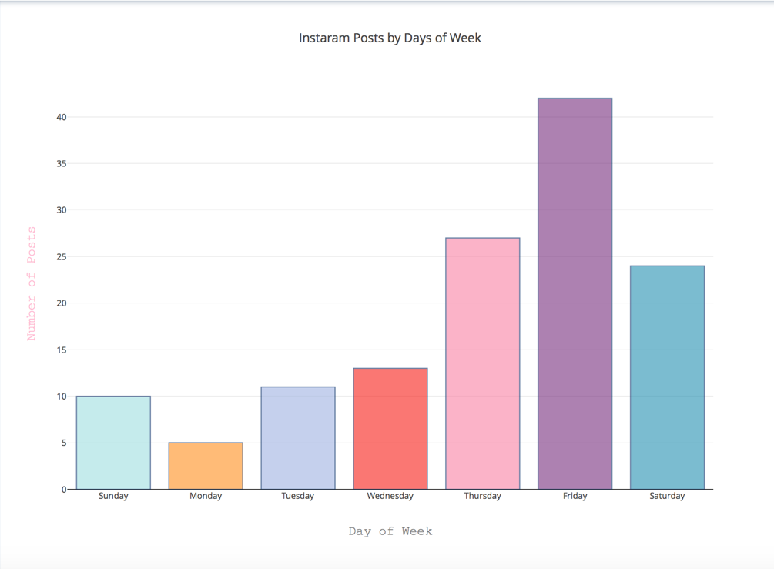

This visualization above has the days of the week on the X axis, and the number of posts on the Y axis. This bar graph, using different colored bars, displays how many posts are posted on each day. As shown above, most of my posts are posted on Fridays.

1. Bubble chart of Instagram post likes

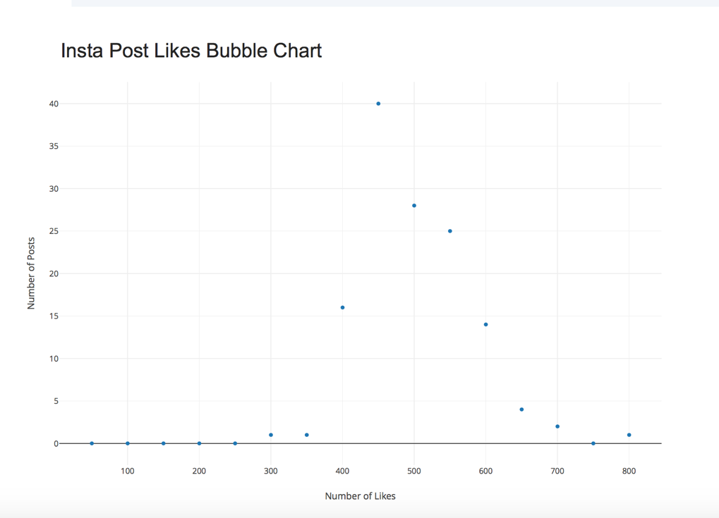

This graph shows how many likes my posts get. The x axis has intervals (intervals of 50) and the Y axis has the number of posts with the amount of likes in that interval. If you hover over a dot on plotly, you can see the exact number of posts each dot represents. A majority of my posts have around 500 likes.

1. Pie chart of movie genres 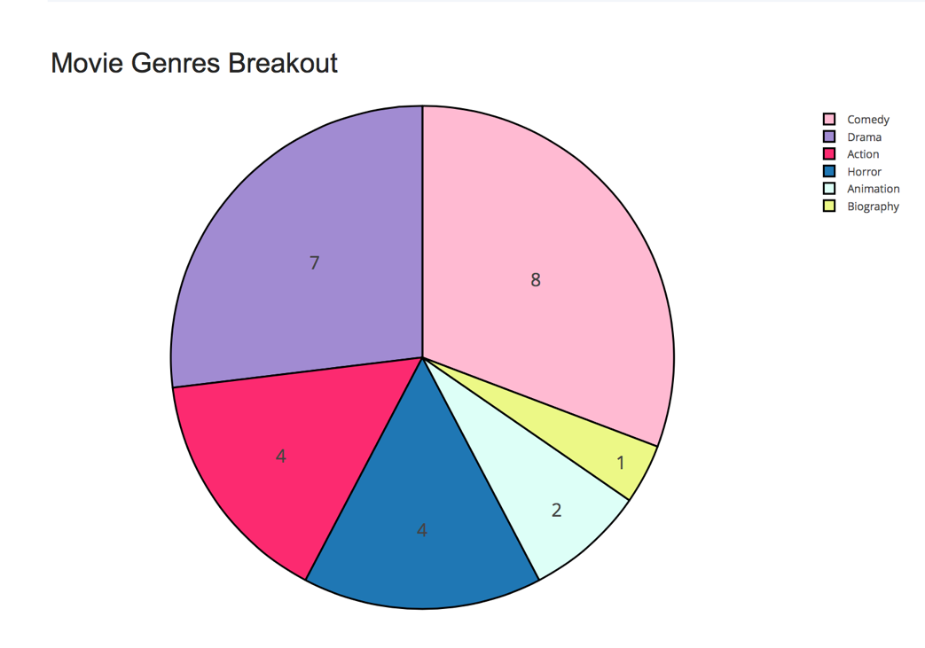

This last visualization is a pie chart, where each sector represents a different genre. The movies that I listed in my code are displayed in this pie chart based off their indicated genre from the IMDB API.